1. **Data Binding**: It is actually communication b/w typescript code (component) and html template.   
   Maybe some calculation happens or from server, some data is fetched which needs to be shown to user and user sees only html template so there must be some kind of communication which is provided by the **Data Binding.**
2. **There are** different kinds of communications?

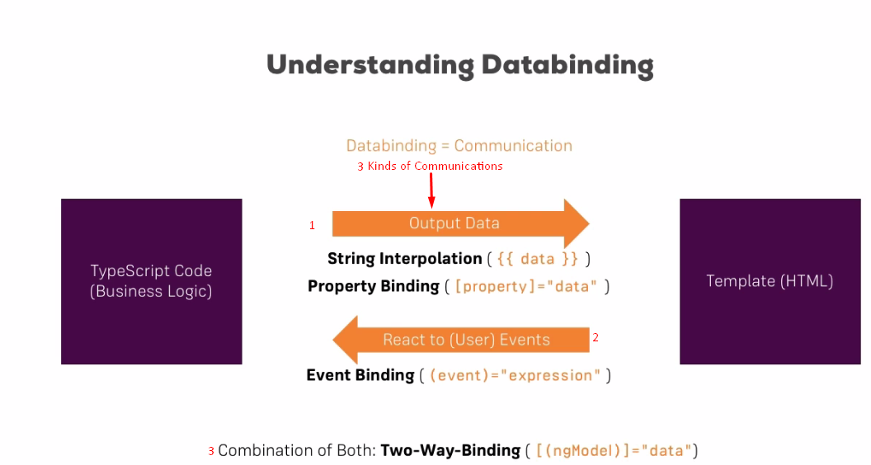

1. There are different kinds of data bindings such as
   1. We want to output data from out TypeScript into the HTML code in the template.
      1. String Interpolation: {{data}}
      2. Property Binding: [property]=”data”
   2. **React to user**: If user clicks a button, we want to call a method in typescript: (eventName)=”expression”
   3. **Two**-**way Binding**: We want to both (reacting to your event and displaying some data in the template)